**Software Requirements and Design Document**

**For**

**Group 7**

Version 1.0

**Authors**:

Sarah Hall

Rachel Russel

Emily Schall

Justin Williams

Ahmed Alaoui

# Overview (5 points)

Grandeur is a 2D platforming puzzle video game. You begin the game in an unfamiliar castle with a large door with 10 individual locks. The goal of the game is to solve puzzles and other tasks to earn the 10 keys to unlock the big main door. Each member will be responsible for 2 “quests” which are either puzzles or achievements that the player must finish in order to beat the game.

# Functional Requirements (10 points)

1. Player movement (walking, jumping, combat, etc) - High
2. Player animations (idle, walking, jumping, etc) - Low
3. Hub room of the main door and side doors - Medium
4. storage/item system - medium
5. settings and save menu - high
6. “quests” screen that shows which keys you have and what is remaining - medium
7. Map of the castle, showing only visited rooms/dungeons - low

# Non-functional Requirements (10 points)

1. smooth movement, smooth abilities
2. enjoyable gameplay
3. able to save data and retrieve saved game data
4. user is not able to modify save data
5. reasonable response time in game

# Use Case Diagram (10 points)

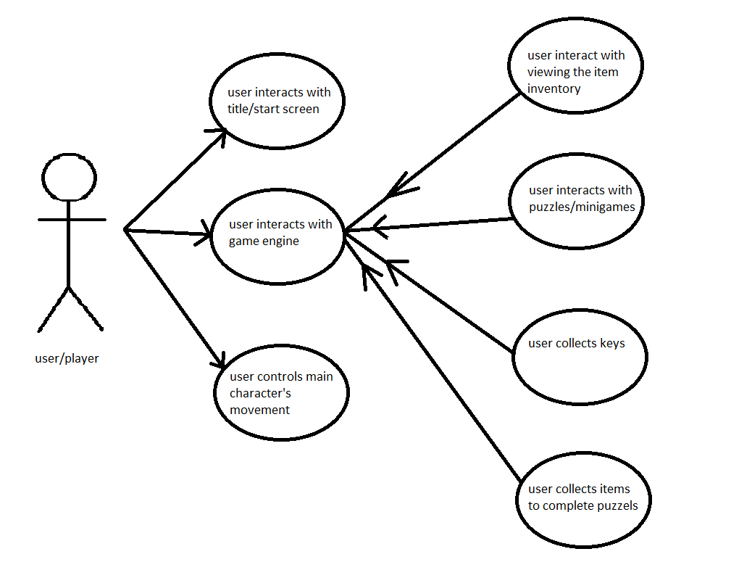

# Class Diagram and/or Sequence Diagrams (15 points)

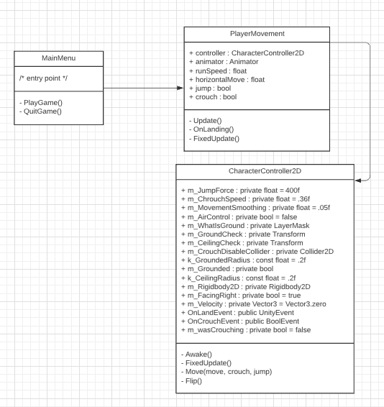

A more detailed class/sequence diagram to be included in the next iteration since there is not much testable code that displays class interactions and the interaction between objects or functions. The general overview of the system (or assumed to be) as follows:

A UIManager script that controls and saves all user info, gameplay, settings, keys found, inventory

Gameplay script that controls player movement

Enemy script the controls general enemy movements

various quest scripts to control each quest

# Operating Environment (5 points)

This video game is made using C# and Unity and will be ported to work on “PC, Mac, Linux, and WebGL”, so any common computer regardless of the OS.

# Assumptions and Dependencies (5 points)

We are currently using free or previously purchased game assets but if time allows, we would like to create our own assets. We plan on using music developed by a local musician and friend, or just using free music.

We are planning on implementing combat but have not fully fleshed out the combat system yet, so that may be scrapped depending on time and if we want to only focus on puzzles and platforms.